Zoid Identification: Exploring Shape Recognition and Human Expertise via Tetris

Song Ye

CogWorks Laboratory, Rensselaer Polytechnic Institute

Zoid Identification: Exploring Shape Recognition and Human Expertise via Tetris

As a new cognitive science research paradigm, Tetris has been a great platform to study extreme expertise and skill acquisition. Relatively simple gameplay makes the game easy to learn, while expert players often times demonstrate different strategies on those basic gameplay. Many elements are abstracted from the game Tetris and studied as independent experiments. Rotations of Zoids is a very important part of Tetris gameplay. This study explores how players deal with Zoid orientation by studying how they identify each Zoid. Experienced player are expected to do a better job by responding faster and more accurate.

**Method**

**Participants**

This study involved 25 participants, who are undergraduate students at Rensselaer Polytechnic Institute. Participants registered for this study in exchange of 1 course credit (given as a fixed amount upon completion of the study) towards a class. Colorblindness information was collected since the graphical interface presented to the participants made heavy use of red and green colors. All of the subjects reported they had typical color visions. All participants were required to take a Gaming History Survey to report their personal gaming experiences, then to complete a Tetris Population Study using Meta-T (Lindstedt & Wayne, 2015) where their Tetris skill levels (criterion scores, high scores, etc.) and play styles (where they were looking at, where they preferred to place a Zoid) were recorded.

**Apparatus and Materials**

Studies took place in a sound-proof chamber with normal lighting. A 20-inch color monitor is used for displaying stimuli, which placed on a table in front of where the participants were sitting. The distance between the monitor and the subject’s eyes was approximately 30 cm long. A Cedrus® RB-834 Respond Pad with custom labeled buttons was used in the study to serve as the only input device for the participant. (See Appendix i for button layouts.) A custom program running on the latest version of PsychoPy2 on a Windows 10 computer was used to present instructions, control the stimuli and collect experiment data. (See Appendix ii for the source code of the program.)

**Procedure**

After participants competed the Game History Survey and the Population Study, they were able to participant in this study. Participants did this experiment individually. Each participant was asked to sit in front of the monitor and to adjust his/her seat to an appropriate height. (Only one participant is allowed in the experiment chamber at a time.) Then a deck of slides are shown to the participant as an introduction. (See Appendix iii for the slides.) Following the instruction, the participant would be logged in with an Experiment ID and being asked with some related demographics information questions.

For the experiment, a participant was presented with the following stimuli: After a short ready cue, a pair of Zoids from the 7 type of Zoids in the Tetris game will appear on the screen, one on the left, the other one on the right, they could come in different orientations. The participant then would compare those two Zoids and determine if they are of the same type or not regardless of the Zoid’d orientation, he/she would respond by pressing the corresponding button on the Respond Pad. After the participant responded, another ready cue followed by a new Zoid pair will appear. Each experiment session contained a total of 605 stimulus divided into 10 blocks, with 60 or 61 pairs of stimulus in each block. (Zoid selection and grouping details will be discussed in the “Design” section below.) In between each blocks, participants are allowed to have a self-paced break, which was up to 3 minutes, and received feedbacks of their performance in the last block. During this break time they were instructed to either speed up or slow down, depending on their performance: speed up if his/her accuracy is above 96%; slow down if his/her accuracy is below 95%. After the break has ended or being skipped, a 10-second countdown timer will start and the participants are being told to get ready for the next block. (See Appendix iv for screenshots of the experiment program.) As a reference, the overall experiment procedure is similar to a typical mental rotation experiment (Shepard, 1971), with Tetris elements, and the participants are not able to directly manipulate the shapes.

**Design**

The makeup of all the 605 stimulus is described below: there are 7 Zoids in the game Tetris, each one is combined from 4 small “squares” and has an intuitive name:

|  |  |  |  |  |  |  |  |
| --- | --- | --- | --- | --- | --- | --- | --- |
| Shape |  |  |  |  |  |  |  |
| Name | O | I | J | L | Z | S | T |

Table 1: Zoid shapes and names

Notice there is a Zoid pair: “J” and “L,” those 2 are actually mirrored shapes. Similarly, “Z” and “S” are mirrored shapes, too.

Just like a player can rotate a Zoid in a Tetris game, in this experiment, for each Zoid, it can appear to be in up to 4 possible orientations: 0°, 90°, 180°, 270°, (participants are not able to actually rotate it on the screen), but if a shape looks exactly the same after rotation, it will not be considered as a possible orientation, here are the possible orientations of all Zoids:

|  |  |  |  |  |  |  |  |
| --- | --- | --- | --- | --- | --- | --- | --- |
| Orientation\Name | O | I | J | L | Z | S | T |
| 0 | Yes | Yes | Yes | Yes | Yes | Yes | Yes |
| 90 | - | Yes | Yes | Yes | Yes | Yes | Yes |
| 180 | - | - | Yes | Yes | - | - | Yes |
| 270 | - | - | Yes | Yes | - | - | Yes |
| Total # of | 1 | 2 | 4 | 4 | 2 | 2 | 4 |

Table 2: Zoid orientations

This results in a total number of 19 Zoid/Orientation combinations. For an easy referencing, each of those is called an “Instance.” In this study, each Instance is paired up with all other Instances, ending up in $19×19=361$“Pairs.” Those are the stimulus displayed to the participant during an experiment, One Instance in the Pair will appear on the left, the other one on the right. In each of the set of 361 Pairs, if 2 Instances are not the same Instance, there will exist another Pair in the set, also containing those 2 Instances, but with swapped left and right locations. Those Pairs are called swapped Pairs. See an example below.



Pair B

Pair A

Figure 1a: swapped Pairs

Out of the 361 Pairs, 61 of them has both Instance of the same Zoid. To the participants, those are the stimulus that has a correct answer of SAME. For the other 300 Pairs, the correct answer should be DIFFERENT. Examples of SAME and DIFFERENT pairs are shown below:



SAME

SAME

DIFFERENT

DIFFERENT

Figure 1b: SAME, DIFFERENT examples

Since there are many more SAME Pairs than DIFFERENT Pairs, a participant can easily blindly guess DIFFERENT and still result in an 80% accuracy. To avoid this from happening, All SAME Pairs in the set are being duplicated by 5 times, ending up with a total of 305 SAME Pairs, and 300 DIFFERENT Pairs in the set. Randomly guessing will result in a roughly 50% accuracy. This added up to 605 Pairs.

For each experiment, all Pairs are in a randomized order, then divided and put into 10 blocks. Algorithm made sure that all SAME Pairs are displayed at least once in every 2 blocks, So that the Pairs or correct response would not cluster, which would make the experiment results less reliable. The SAME button on the Respond Pad is decorated in green, and DIFFERENT button in red. There are also green/red clues displayed on the screen to hint the participants of the positions of those buttons, so they can focus more on the screen, rather than frequently looking down on the Respond Pad. Button positions are manually swapped between-subject, to randomize the effect of button positions.

**Results & Discussion**

**Analysis on SAME Pairs**

Results shown in this sub-section are all based on analysis on Pairs that has SAME as correct responses.

First, from Figure 2a-d shown below, expert players (figure 2d) respond faster and they either rotate faster or they can recognize the shapes without rotating them. A significant effect is demonstrated by the T Zoid if we compare it to L Zoid and J Zoid: All those 3 Zoids have 4-way rotations. When it comes to L Zoid and J Zoid, they are confusing to the participants. Both low (figure 2b) and high skilled players showed some level of mental rotation behavior. And high-skill player is doing it faster. As to the T Zoid, the general response time is lower, but the players still did mental rotation. The expert players almost had a “flat line,” that is, little response time difference between different absolute degree differences. It can be the case that expert players are better at mental rotation than low-skill players. But it does not explain why the T Zoid has a dramatic response time difference decrease. So it is more likely to be the case that expert player are aware of the fact that in, the Tetris game, unlike J Zoid and L Zoid are confusable, there is no Zoid that can be confused with the T Zoid.

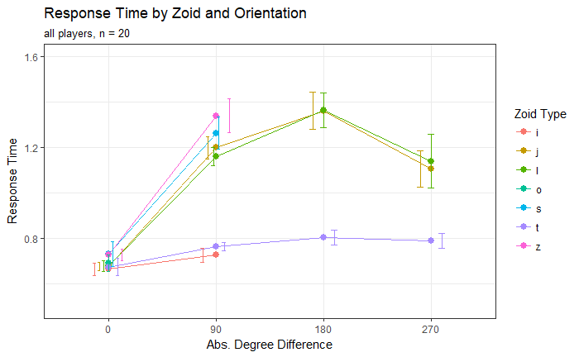 Figure 2a: Response Time and Orientation (All players)

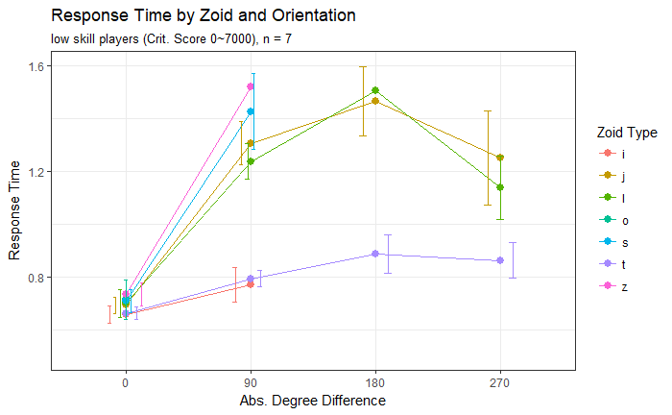

Figure 2b: Response Time and Orientation (Low-skill players)

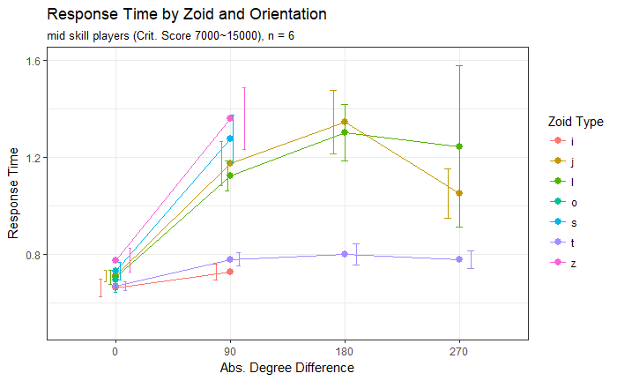

Figure 2c: Response Time and Orientation (Mid-skill players)

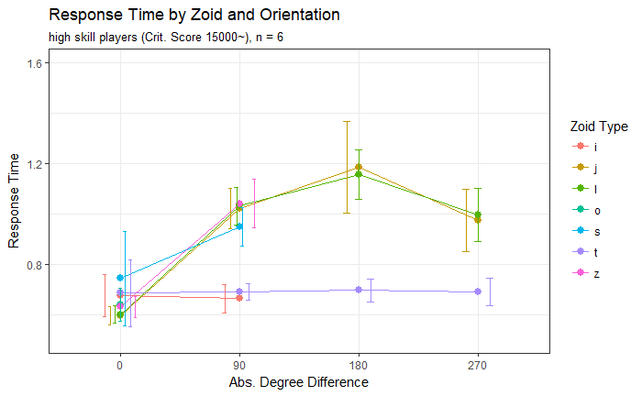

Figure 2d: Response Time and Orientation (High-skill players)

Shown in Figure 3a, For the L Zoid and J Zoid, there is a difference between how subjects treat them: From the individual graphs in the visualization program, some participants are rotating J Zoid in one direction and L Zoid in another. Some are rotating them in one direction, but one is faster, one is slower.

Similar differences can be found in Z Zoids and S Zoids. (Figure 3b) There are also individual plots in the visualization program. 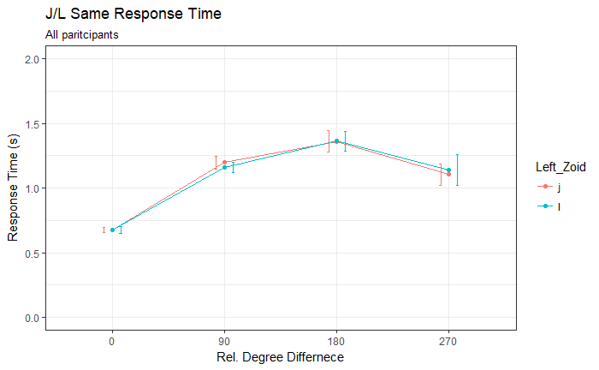

Figure 3a: J/L Response Time for SAME Pairs

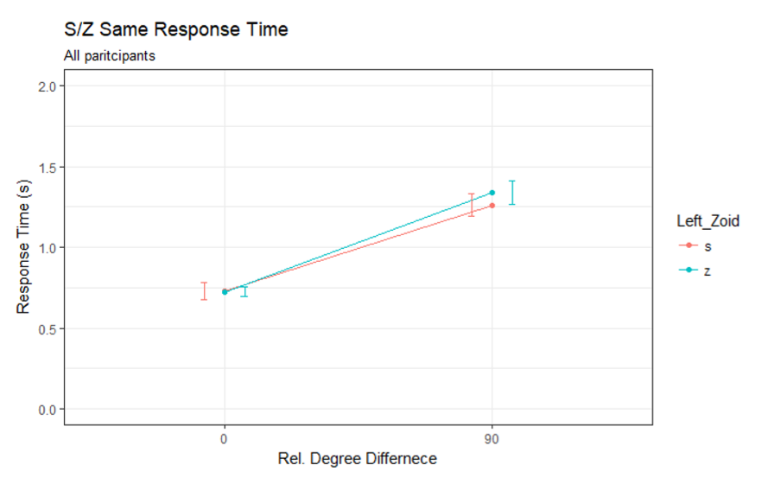

Figure 3b: S/Z Response Time for SAME Pairs

**Analysis on ALL Pairs**

Results shown in this sub-section are all based on analysis on all Pairs, including both SAME and DIFFERENT Pairs.

Figure 4 and 5 shows by doing more blocks participants are more familiar with the study, thus, preforming much better and stable around block 5 to 7. One note is that most participants are following the instructions at the block breaks. As the percentage of correct dropped after 97% and converged at around 96%.

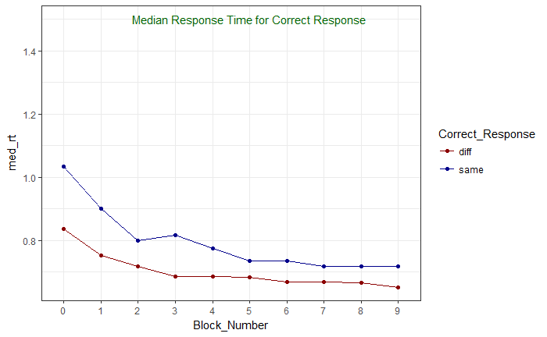

Figure 4: Median Response Time for Correct Response

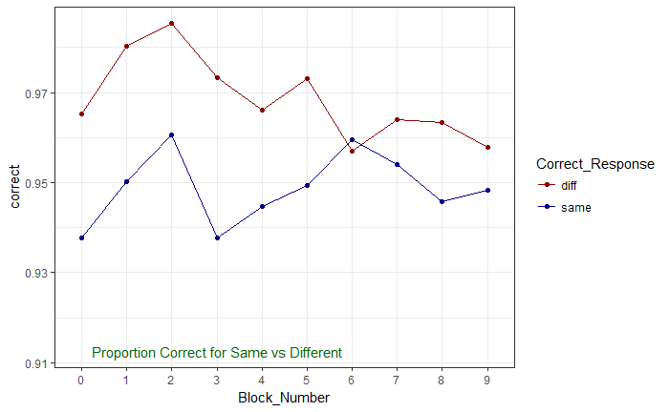

Figure 5: Percent Correct for Same vs Different

This figure 6a,b below shows the response time trend of confusable pairs’ rotation in each levels of skill.

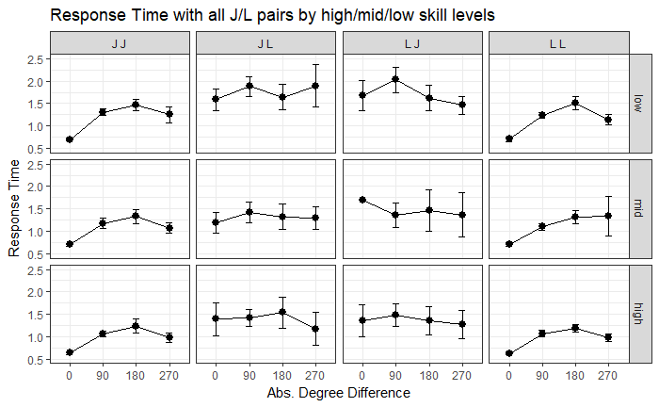

Figure 6a: Response Time for all Confusable Pairs (J/L)

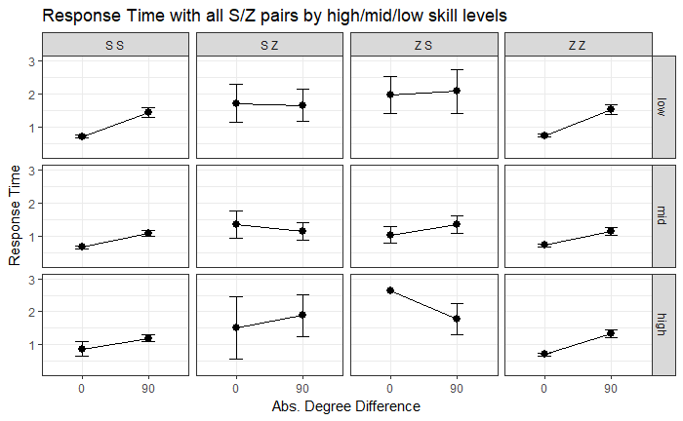

Figure 6a: Response Time for all Confusable Pairs (S/Z)

**Future Studies**

1. Zoid ID “Time Trial”: Give the participant blocks of 4-minute timed challenge, stimulus show up one after another, endlessly. Evaluate by $(hit-misses)/minute$.

**References**

Lindstedt, J., & Wayne, G. D. (2015). Meta-T: Tetris(R) as an experimental paradigm for cognitive skills research. *Behavior Research Methods*.

Shepard, R. N. (1971). Mental Rotation of Three-Dimensional Objects.

Sibert, C., Gray, W. D., & Lindstedt, J. K. (2017). Interrogating Feature Learning Models to Discover Insights Into the Development of Human Expertise in a Real-Time, Dynamic Decision-Making Task. *Topics in Cognitive Science*, 374–394.

Tarr, M. J., & Pinker, S. (1989). Mental Rotation and Orientation-Dependence in Shape recognition. *Cognitive Psychology*, 233-282.

**Appendix**

1. **Respond Pad Layout**

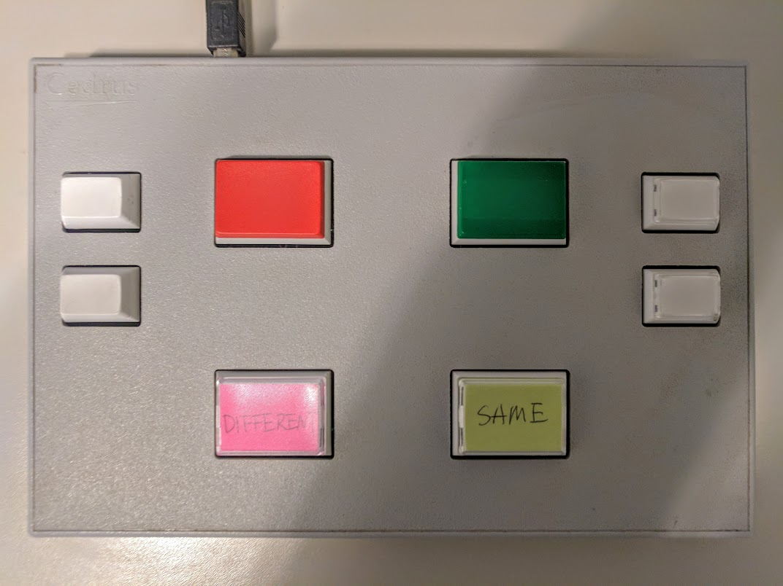

1. **Github:** <https://github.com/CogWorks/Zoid_ID/tree/master/PsychoPy%20Code>
2. **Github:** <https://github.com/CogWorks/Zoid_ID/tree/master/instructions>
3. **Github:** <https://github.com/CogWorks/Zoid_ID/tree/master/r_code>
4. **Github Folders and Contents:** [**https://github.com/CogWorks/Zoid_ID/blob/master/Contents.pdf**](https://github.com/CogWorks/Zoid_ID/blob/master/Contents.pdf)